Zoom Top Tips
Always use a password
Open the Zoom App
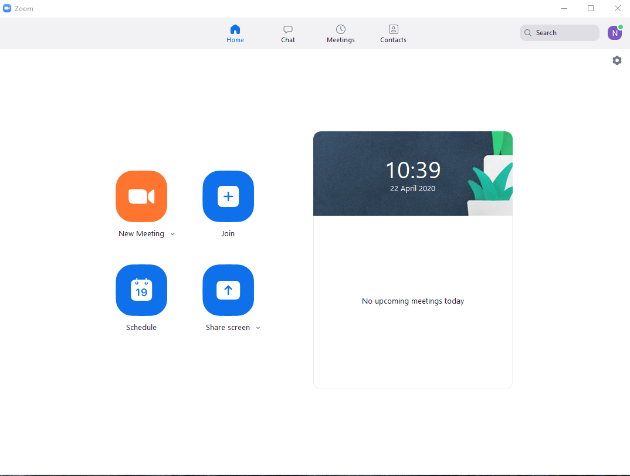
Go to Schedule Meeting
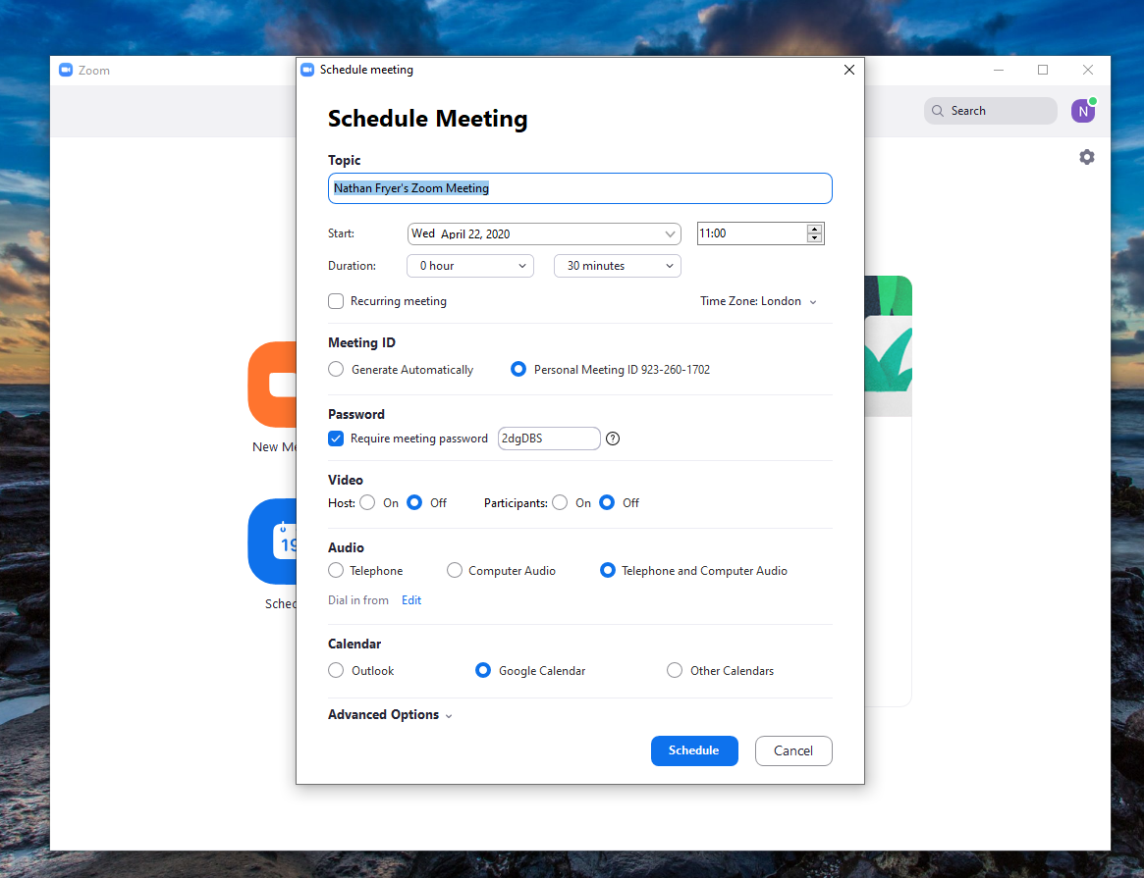
Use a secure, 10-character password

Enable the Waiting Room
Go to Schedule Meeting
Go to the advanced options
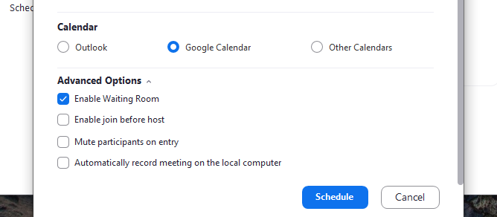
Enable the waiting room

Lock the Meeting
Once everyone that you want in the meeting is in the meeting, you can then lock the meeting, so no-one else can join.
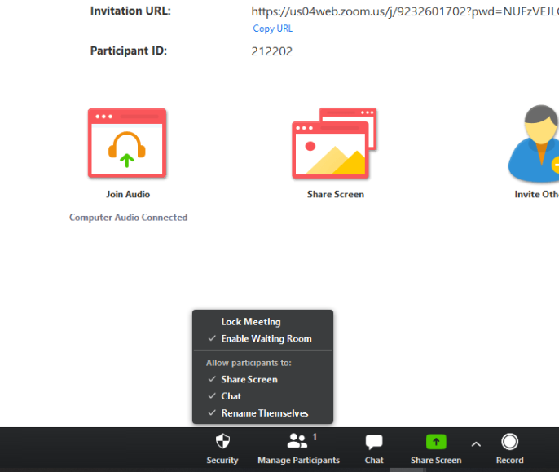

Allow clients not to have to download the Zoom App
This only works when accessing via a desktop device.
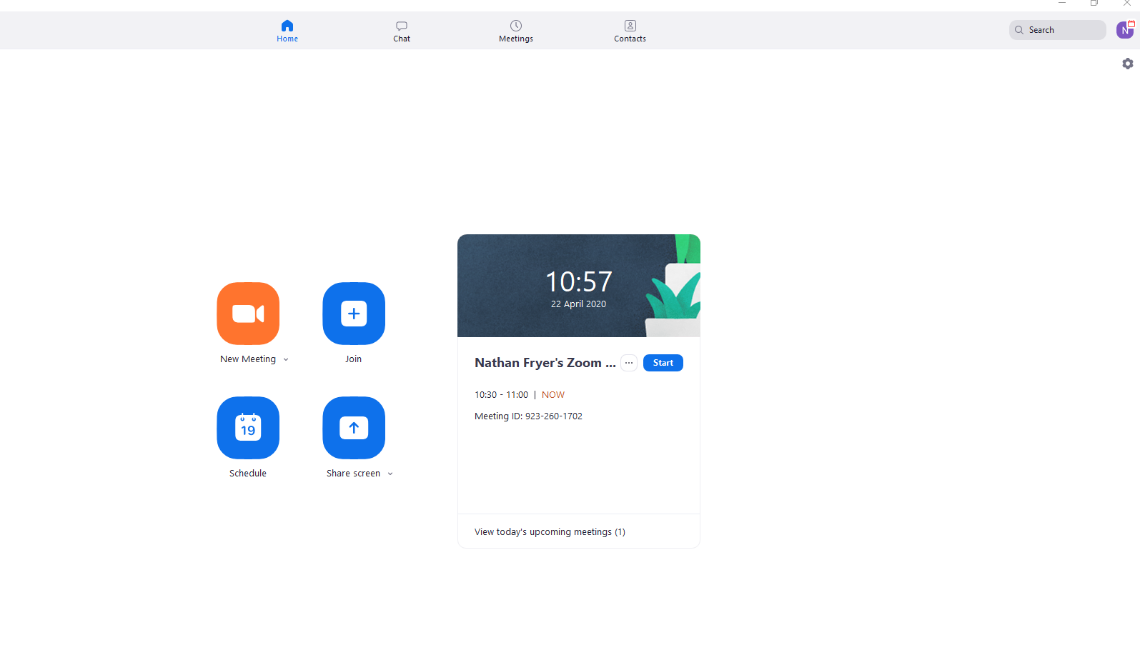
Go to settings
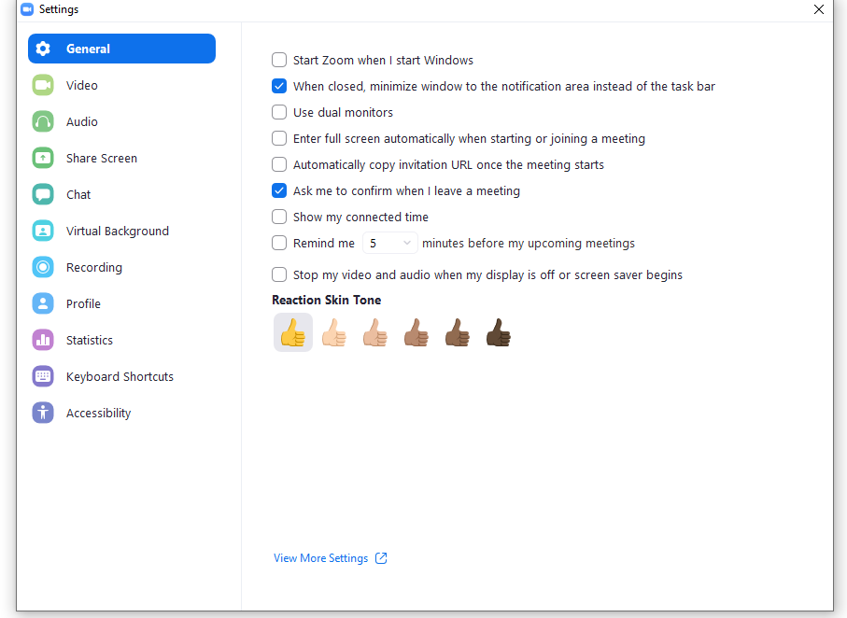
View more settings

This will take you to the website
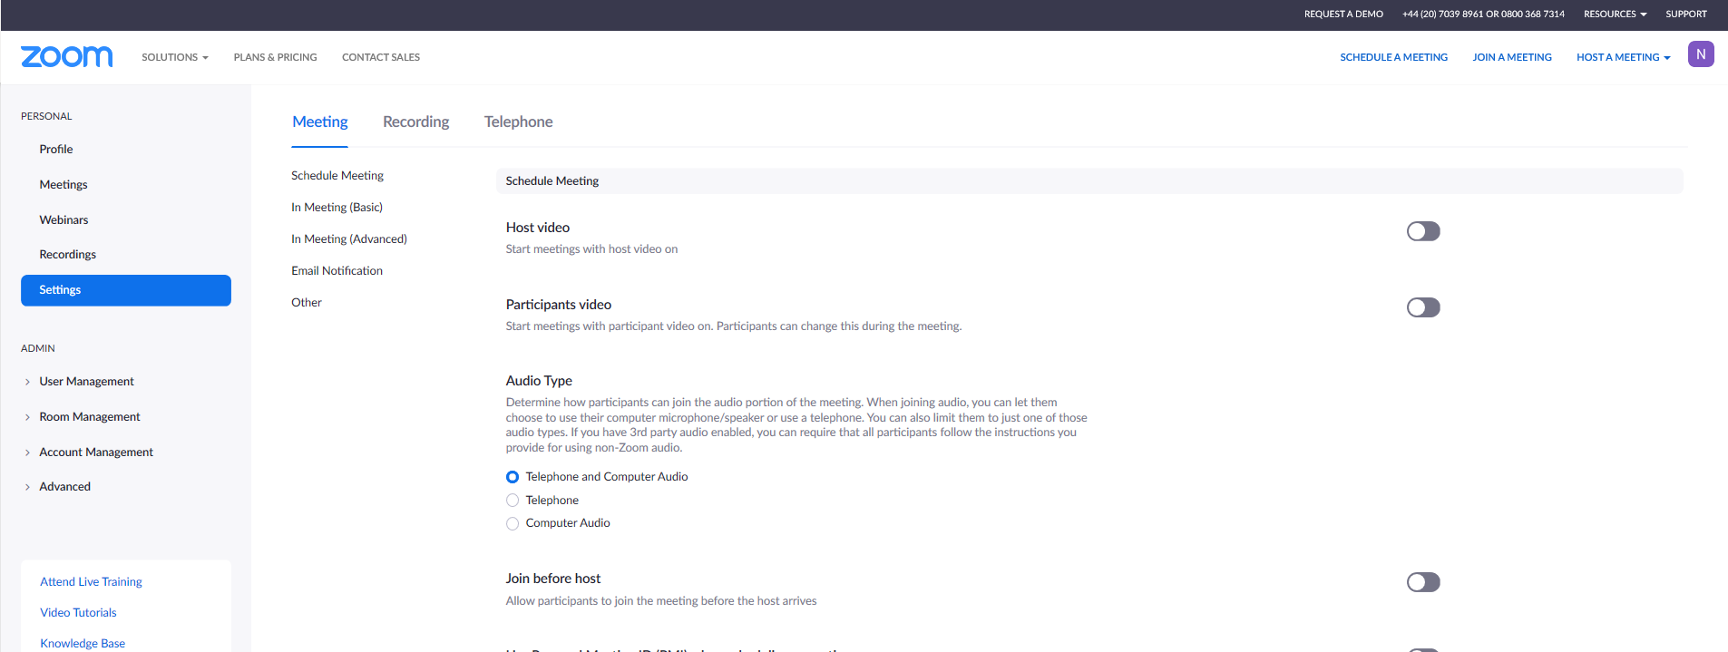

Go to In Meeting (Advanced)
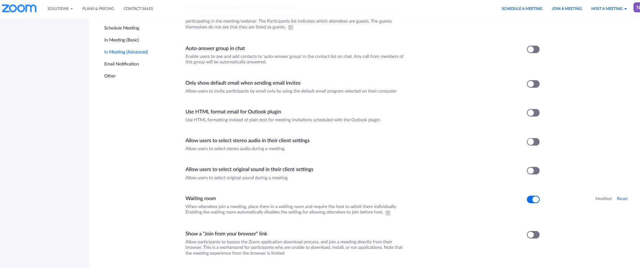
Activate the Share a “Join from your Browser Link”

Keep your Zoom App up to date
Zoom is responding to the increased demand and is implementing security updates regularly.

